EXPERIMENT
AIM:
Develop a simulation to demonstrate multiple access protocols such as pure ALOHA , slotted ALOHA , CSMA/CD and using Cisco packet Tracer . Analyze the performance of each protocol in handling network collisions and maximizing data transmission efficiency.
PROCEDURE: PURE ALOHA
- Open Cisco Packet Tracer and create a new project
- Add devices
. Drag and drop 4-6 PCs
. Add 1 Hub -PT
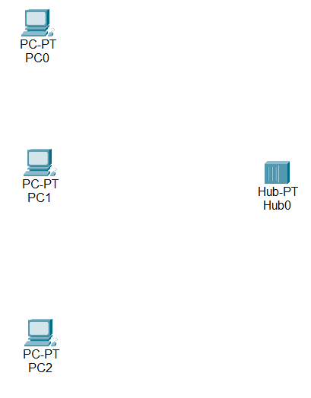

- Connect devices
. Use Copper straight through cable
. Connect all PCs to the hub
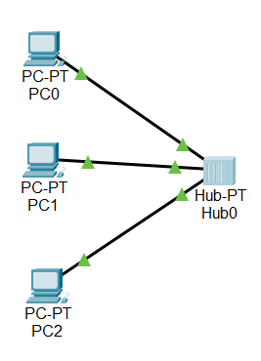
- Configure IP Addresses
. Assign IP addresses to each PC in the same network
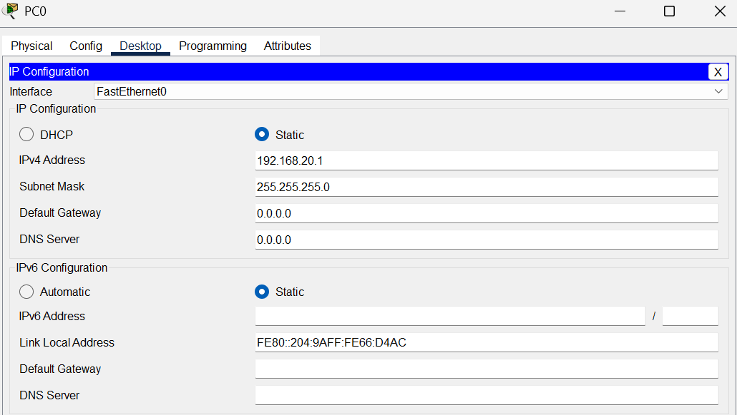

- Simulate data transmission
. Use add simple pdu tool
. send packets between different PCs
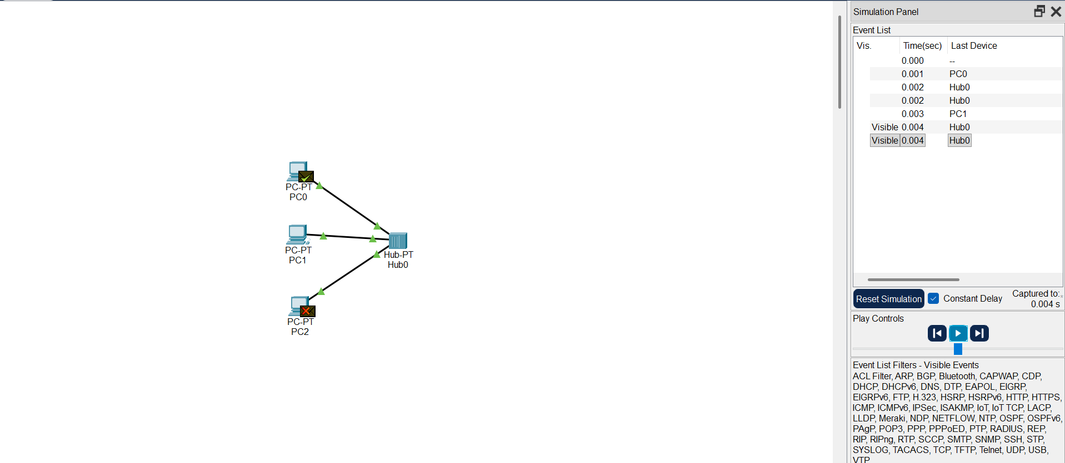

OBSERVE:
- PACKET FLOW THROUGH HUB:
In the hub broadcasts packets to all devices but only the destination accepts it.
- COLLISIONS BETWEEN PACKETS:
When multiple devices send data simultanesously packets overlap , causing collisions .
- RETRANSMISSION AFTER COLLISION:
After collision , data is lost and devices retransmit after a random delay

CSMA/CD (Switch- based network)

PROCEDURE:
1. Open cisco packet tracer and create a new project .
2. Add devices:
. Drag and drop 4-6 PCs
. Add 1 switch(2960)
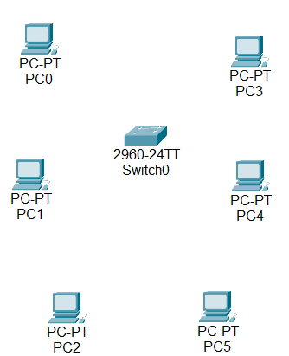
- C ONNECT DEVICES
. Use copper straight through cable
. connect all PCs to the switch
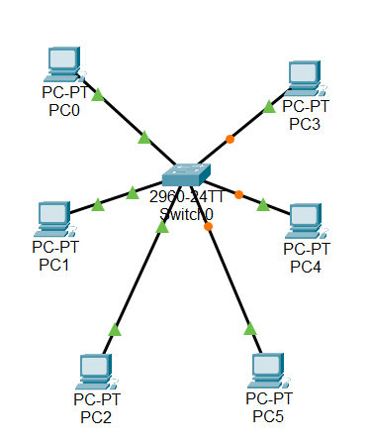

- Configure IP Addresses
.Assign IP Addresses in the same network
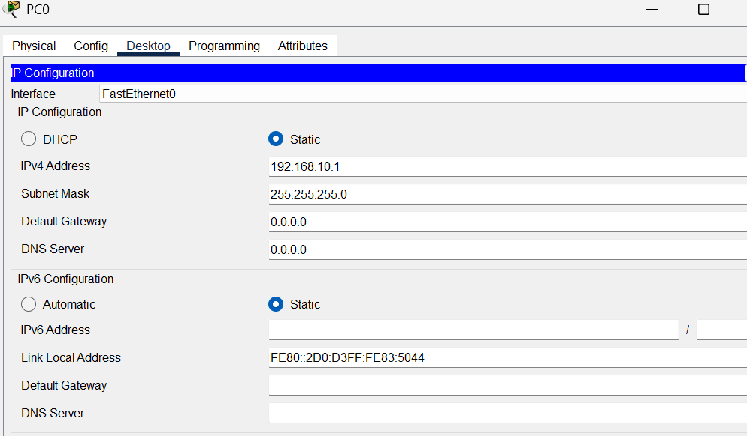

- Simulate data transmission
. Use ADD SIMPLE PDU
. send packets between different PCs
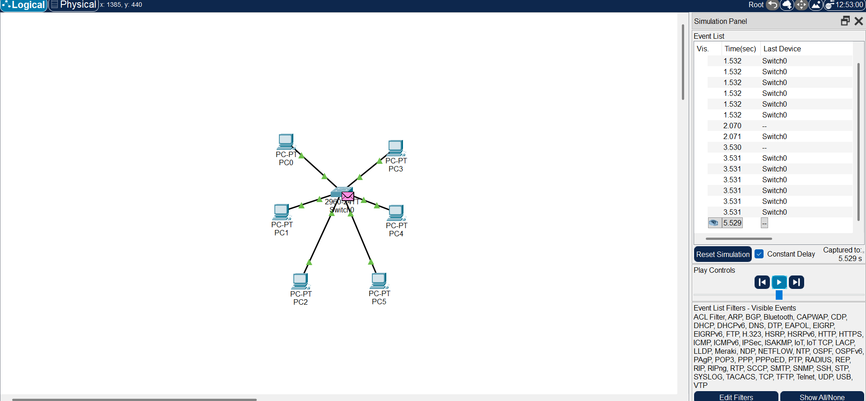

OBSERVE:
. Packet flow through switch
. collision handling
. data transmission efficiency

